Samsung S5/6S/S7

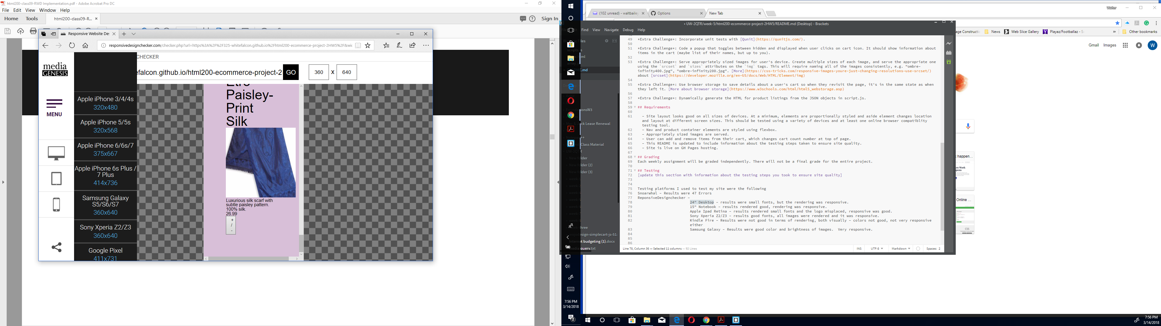

Apple 7

